Public Quarterly Report

Date of Report: 2nd Quarterly Report-March 31, 2023
Contract Number: 693JK322RA0001
Prepared for: US Pipeline and Hazardous Materials Safety Administration
Project Title: Rapid Ultraviolet (UV) Cured Adhesive for Gas Main Cured-in-Place-Lining (CIPL)
Prepared by: Progressive Pipeline Management
Contact Information: Casey Giambrone, cfg@progressivepipe.com, 631-339-3075
For quarterly period ending: March 31, 2023

1: Items Completed During this Quarterly Period:

Item # | Task # | Activity/Deliverable | Title | Federal Cost | Cost Share
1 | 1 | Adhesive Development and Preparation | Adhesive Development and Preparation | $- | $-
2 | 2 | Develop variations of adhesive - 3 versions | Develop variations of adhesive - 3 versions | $4,500.00 | $4,500.00
3 | 3 | "Conduct in-house preliminary coupon testing (Adhesive only)  - Cure - UV light intensity and wave length (5 coupons per adhesive version)  - ASTM D2240 Hardness (5 coupons per adhesive version)  - ASTM D4541 Pull off strength testing using steel plate (5 coupons per adhesive version)" | "Conduct in-house preliminary coupon testing (Adhesive only)  - Cure - UV light intensity and wave length (5 coupons per adhesive version)  - ASTM D2240 Hardness (5 coupons per adhesive version)  - ASTM D4541 Pull off strength testing using steel plate (5 coupons per adhesive version)" | $1,125.00 | $1,125.00
4 | 4 | "Prepare and ship coupon samples for developed adhesives | "Prepare and ship coupon samples for developed adhesives  - Prepare 5 coupons per adhesive version (15 total)" | $600.00 | $600.00
6 | 6 | Internal Vortex meetings to update on progress (2hr x 4 ppl)  - Review of results & Circle back to Task 2.1, if needed | Internal Vortex meetings to update on progress (2hr x 4 ppl)  - Review of results & Circle back to Task 2.1, if needed | $14,400.00 | $14,400.00
7 | 7 | 1st Quarterly Status Report & Data Analysis | 1st Quarterly Status Report & Data Analysis | $13,680.00 | $13,680.00
 |  | (Project not started until January 2023)

2: Items Not-Completed During this Quarterly Period: (Project not started until January 2023)

Item # | Task # | Activity/Deliverable | Title | Federal Cost | Cost Share
5 | 5 | ASTM D543 Chemical Resistance with chemicals from ASTM F2207 (5 coupons per adhesive version per chemical [10], 150 total samples) | ASTM D543 Chemical Resistance with chemicals from ASTM F2207 (5 coupons per adhesive version per chemical [10], 150 total samples) | $19,819.50 | $19,819.50

3: Project Financial Tracking During this Quarterly Period:

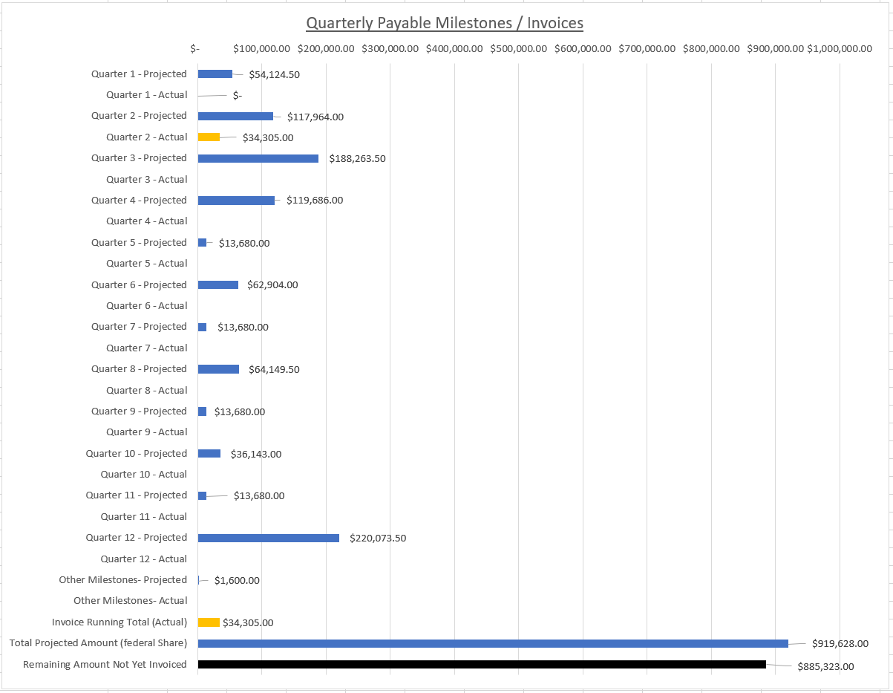

4: Project Technical Status –

Item No. 1.1 & 2.2 (Adhesive Development and Preparation)

We researched various chemical compounds and classifications of polymers to understand which polymers offered the greatest potential for high strength, controllable bond, rapid force cure and high temperature deflection as a CIPL adhesive. Common knowledge of Cured-in-place-liner (CIPL) led us to begin evaluating thermoplastics, specifically epoxies for their high strength/bond and acrylics for their cure stability. We quickly learned that epoxies have very limited cure mechanisms and are often not conducive to UV curing unless deployed as a hybrid adhesive. Methacrylate polymers are derived from acrylic monomers and amidst industry are most often UV cured, therefore we evaluated a variety of such oligomers, monomers and propriety additive combinations to target the desired strength and cure speed. Once our strengths and viscosities were dialed in, we further trialed a variety of additives to yield the appropriate bond strength amongst 3 versions. After preliminary tensile, flexural, compressive and pull-off test results were achieved, the final step was to fine-tune the photo-initiators to be appropriately reactive with commercially available UV light trains at the intensity of 40mW/cm2 and a wavelength of 395nm (most commonly used with CIPL and CIPP applications).

Exhibit A. (Preliminary physical property testing)

Laboratory LED curing of Raw Resin Samples | 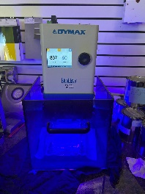
Wet-out of Trial Felt Samples | 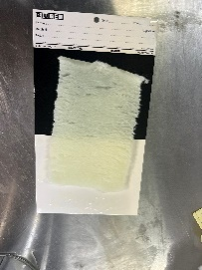
Cured Felt Sample | 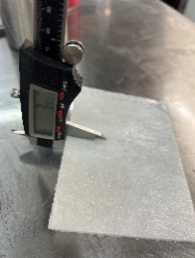
Development of Felt Face Plate Samples (Coupon Sample) | 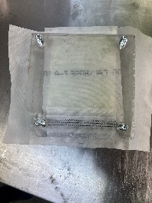
Preliminary Physical Properties Testing | 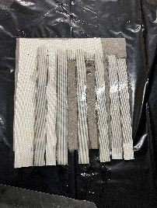

Exhibit B. (Bench testing – Cure speed and preliminary UV light train compatibility)

Equipment Evaluation | 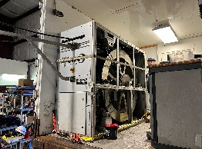
Equipment Calibration | 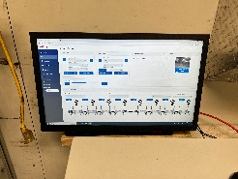
Bench Testing of UV Light Train Compatibility | 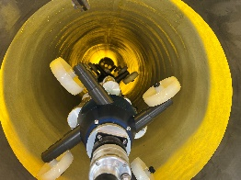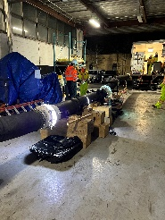

Item No. 3.3 (In-house preliminary resin evaluation and coupon testing)

This task was immediately commenced after task 2.2. To establish the Wavelength and Intensity of the curing light to be used, a visit was conducted to PPM’s facility in New Jersey. We used a radiometer to establish the light intensity of the available UV system that would be used in the field and in later stages of R&D and determined the minimum operating intensity of 40 mW/cm2. This value was then compared to the published technical data of all commercially available mainline UV curing units in the Unites States; the value was determined to be well within the average operating intensities on the market. The lights themselves are set to a 395nm peak wavelength and this was verified by the radiometer as well; this value was also determined to be the market norm for mainline curing units as well as the preferred wavelength for much of the additives market. We calibrated our laboratory UV oven to match these 2 specifications. Hardness and pull-off testing was selected as the critical secondary resin KPIs because hardness is a primary indicator of a fully polymerized adhesive (fully cured or full depth of cure) and pull-off strength must be conducive to the specified CIPL failure mode. Five adhesive coupons were prepared per adhesive version and in accordance with ASTM D2240 and a modified ASTM D4541 (peel test as opposed to pull test) which are widely referenced across the CIPL industry and in installation practices.

Exhibit C. (Coupon casting for 3 adhesive versions)

3 Resin Variations (Cast resin samples only) | 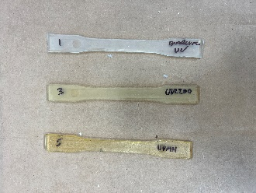
Depth of Cure Analysis | 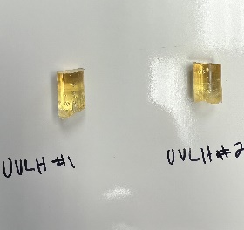

Exhibit D. (ASTM D2240 Hardness testing)

Hardness Testing 1 | 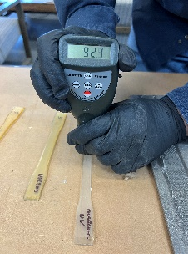
Hardness Testing 2 | 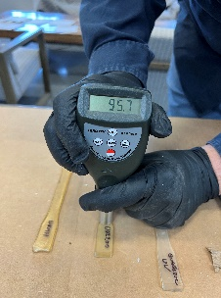
Hardness Testing 3 | 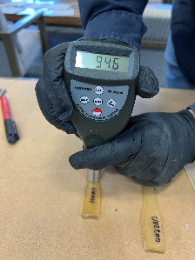

Exhibit E. (ASTM D4541 Pull-off testing)

Blasted Steel Plate for Samples | 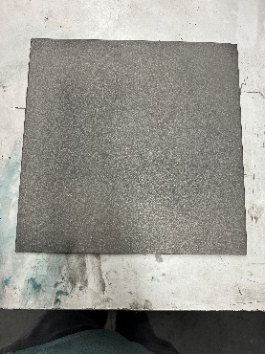
Prepared Samples | 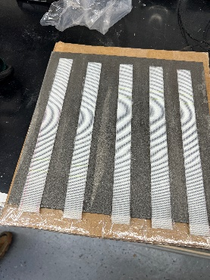
Set Up | 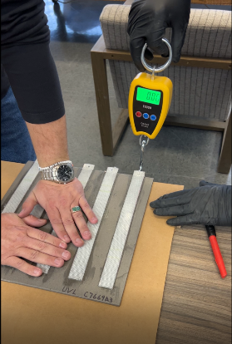
Pull-off Process | 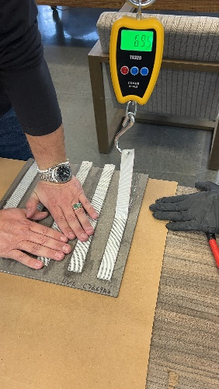
Post-test Sample | 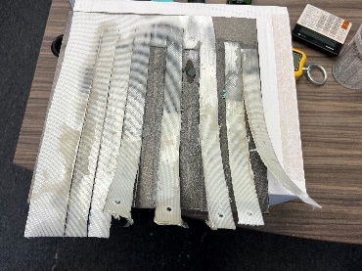

Item No. 4.4 (Prepare and ship in-house coupons to Vortex/PPM facility for final preliminary bench evaluation)

Coupon or plate samples like those shown in Exhibit A. were prepared and shipped to PPMs facility in New Jersey for additional qualitative testing and observation of the final three resin variations. Additional strength physical properties such as compressive, flexural, and tensile strength were observed relative to other CIPL resins in the market. These tests were performed with Vortex equipment and not by a third-party laboratory and served as a key final checkpoint prior to production of 150 samples for chemical testing at CUB (Item No. 5.5).

Exhibit F. (Preliminary Strength Results)

UV Variation #1
Characteristics | Test method | Performance | Unit
Young’s modulus | ASTM D638 | > 348,090 | psi
Tensile strength | ASTM D638 | > 7,251 | psi
Elongation at break | ASTM D638 | > 5 | %
Flexural modulus | ASTM D790 | > 232,060 | psi
Flexural strength | ASTM D790 | > 7,251 | psi

UVL Variation #2
Characteristics | Test method | Performance | Unit
Young’s modulus | ASTM D638 | > 435,113 | psi
Tensile strength | ASTM D638 | > 5,801 | psi
Elongation at break | ASTM D638 | > 2 | %
Flexural modulus | ASTM D790 | > 333,586 | psi
Flexural strength | ASTM D790 | > 10,152 | psi

UVLH Variation #3
Characteristics | Test method | Performance | Unit
Young’s modulus | ASTM D638 | > 435,113 | psi
Tensile strength | ASTM D638 | > 8,702 | psi
Elongation at break | EN ISO 527 | > 2 | %
Flexural modulus | ASTM D638 | > 2200 | psi
Flexural strength | ASTM D790 | > 8,702 | psi

Item No. 5.5 (Chemical Resistance Sample Preparation and Testing – Partially Completed this Quarter)

After attempting to create samples utilizing the traditional coupon method, which incorporate silicone molds to create 12”x12” plates which are then cut to conform to the desired test, we discovered the bond strength of the resin’s samples combined with a quick UV cure was causing the samples to bow. We consulted with several laboratories and UV additive suppliers to investigate UV curing sampling best practices and decided it was best to procure a custom milled mold for the upcoming chemical test which allowed us to create the coupons without any deformities and inconsistencies.

Exhibit G. (Chemical Resistance Sample Preparation Process)

Initial dog-bone coupons failed | 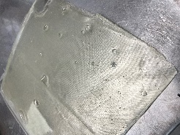
Pouring and Weighing of Samples | 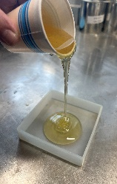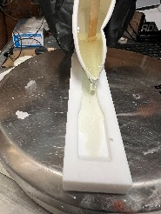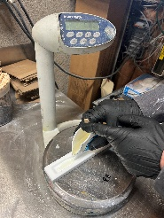
Version 3 of dog-bone sample mold | 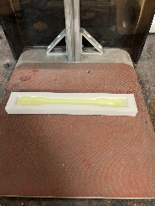
Final cured dog-bone sample for chemical resistance | 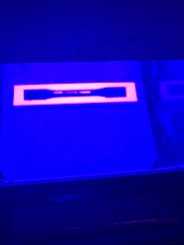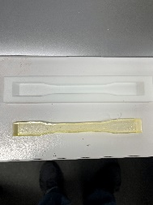
150 Completed Samples | 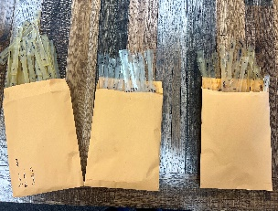

Item No. 6.6 (Vortex Internal Review)

The Vortex team met several times throughout the week of March 26th to compile the data in this report as well as index the project photos and timeline. The quarterly report within was assembled on March 28th between Matt Peterson, Scott Podhaisky and Andrew Gonnella. Relying upon vast industry knowledge, application experience and having developed and successfully commercialized CIPP and CIPL resins many times over the last decade, Vortex was able to establish 3 potentially viable resin variations after a few rounds of bench trials over the course of several weeks. The most challenging component of tasks 1-4 were establishing the tools and processes to efficiently and consistently produce samples for a newer set of industry standards. Within this quarter, half of task 5.5 was completed. With 150 dog-bone coupons ready to ship to CUB for chemical resistance testing, we are confident much progress and time will be made up for in quarter 3 of the project.

5: Project Schedule –

- Items not complete in Q2, expected to be included in the Q3 report are as follows:

Item # | Task # | Activity/Deliverable | Title
5 | 5 | ASTM D543 Chemical Resistance with chemicals from ASTM F2207 (5 coupons per adhesive version per chemical [10], 150 total samples) | ASTM D543 Chemical Resistance with chemicals from ASTM F2207 (5 coupons per adhesive version per chemical [10], 150 total samples)
8 | 8 | Initial Testing of Adhesive & Liner Plate Samples | Initial Testing of Adhesive & Liner Plate Samples
9 | 3 | Conduct in-house preliminary coupon testing (Adhesive & Liner)  - Cure - UV light intensity, wave length and light penetration of liner (5 coupons per adhesive version)  - ASTM D2240 Hardness (5 coupons per adhesive version)  - ASTM D4541 Pull off strength testing using steel plate (5 coupons per adhesive version) | Conduct in-house preliminary coupon testing (Adhesive & Liner)  - Cure - UV light intensity, wave length and light penetration of liner (5 coupons per adhesive version)  - ASTM D2240 Hardness (5 coupons per adhesive version)  - ASTM D4541 Pull off strength testing using steel plate (5 coupons per adhesive version)
10 | 9 | Prepare and ship coupon samples for initial testing  - Prepare 15 coupons per adhesive version | Prepare and ship coupon samples for initial testing  - Prepare 15 coupons per adhesive version
11 | 10 | ASTM D790 Flex Mod/Strength (5 coupons per adhesive version - 15 samples)  ASTM D638 Tensile (5 coupons per adhesive version - 15 samples)  ASTM D695 Compression Strength (5 coupons per adhesive version - 15 samples) | ASTM D790 Flex Mod/Strength (5 coupons per adhesive version - 15 samples)  ASTM D638 Tensile (5 coupons per adhesive version - 15 samples)  ASTM D695 Compression Strength (5 coupons per adhesive version - 15 samples)
12 | 11 | ASTM D3167 Peel Resistance (5 coupons per adhesive version - 15 samples) | ASTM D3167 Peel Resistance (5 coupons per adhesive version - 15 samples)
13 | 12 | Internal Vortex meetings to update on progress (2hr x 4 ppl)  - Review of results & Circle back to Task 2.1, if needed | Internal Vortex meetings to update on progress (2hr x 4 ppl)  - Review of results & Circle back to Task 2.1, if needed
14 | 13 | Prepare and ship adhesive for bench testing to PPM (2x40ft @ 8"x6mm) | Prepare and ship adhesive for bench testing to PPM (2x40ft @ 8"x6mm)
15 | 14 | Travel to PPM for bench testing phase 1 | Travel to PPM for bench testing phase 1
16 | 15 | Optimize PPM light train speed & intensity  - Radiometer and Cure Chart | Optimize PPM light train speed & intensity  - Radiometer and Cure Chart
17 | 16 | Radiometer Utilization | Radiometer Utilization
18 | 17 | Review results of initial testing of adhesive with Vortex | Review results of initial testing of adhesive with Vortex
19 | 18 | UV Light Train Utilization (i.e. equipment upgrades) | UV Light Train Utilization (i.e. equipment upgrades)
20 | 7 | 2nd Quarterly Status Report & Data Analysis | 2nd Quarterly Status Report & Data Analysis

